**Experiment 11**

**Part 1**

importjava.util.*;

public class Inheritance {

public static void main(String[] args) {

Scanner sc = new Scanner(System.in);

System.out.println("1.Teacher\n2.Officer\n3.Regular typist\n4.Casual typist");

int c = sc.nextInt();

switch(c) {

case 1:

Teacher t1 = new Teacher();

t1.read();

t1.display();

t1.showLeaves();

break;

case 2:

Officer o1 = new Officer();

o1.read();

o1.display();

o1.showLeaves();

break;

case 3:

Regular r1 = new Regular();

r1.read();

r1.display();

r1.showLeaves();

break;

case 4:

Casual c1 = new Casual();

c1.read();

c1.display();

c1.showLeaves();

break;

default:

System.out.println("Invalid choice.");

}

}

}

abstract class Staff {

Scanner sc;

String name;

long id;

void read() {

sc = new Scanner(System.in);

System.out.print("State your name: ");

name = sc.next();

System.out.print("State your id: ");

id = sc.nextLong();

}

void display() {

System.out.println("Name: " + name);

System.out.println("ID: " + id);

}

abstract void showLeaves();

}

class Teacher extends Staff {

String sub;

intexp;

void read() {

super.read();

System.out.print("State your subject: ");

sub = sc.next();

System.out.print("State your experience in years: ");

exp = sc.nextInt();

}

void display() {

super.display();

System.out.println("Subject: " + sub);

System.out.println("Experience: " + exp + " years");

}

voidshowLeaves() {

System.out.println("Number of leaves granted: 15");

}

}

class Officer extends Staff {

String pos;

void read() {

super.read();

System.out.print("State your position: ");

pos = sc.next();

}

void display() {

super.display();

System.out.println("Position: " + pos);

}

voidshowLeaves() {

System.out.println("Number of leaves granted: 20");

}

}

class Typist extends Staff {

double speed;

intexp;

void read() {

super.read();

System.out.print("Enter your speed: ");

speed = sc.nextDouble();

System.out.print("Enter your experience in years: ");

exp = sc.nextInt();

}

void display() {

super.display();

System.out.println("Speed: " + speed);

System.out.println("Experience: " + exp + " years");

}

voidshowLeaves() {

System.out.println("Number of leaves granted: 10");

}

}

class Casual extends Typist {

int pay, days;

void read() {

super.read();

System.out.print("Enter your pay: ");

pay = sc.nextInt();

System.out.print("Enter the number of working days: ");

days = sc.nextInt();

}

void display() {

super.display();

System.out.println("Pay: " + pay);

System.out.println("Number of working days: " + days);

}

}

class Regular extends Typist {

int pay;

void read() {

super.read();

System.out.print("Enter your salary: ");

pay = sc.nextInt();

}

void display() {

super.display();

System.out.println("Salary: " + pay);

}

}

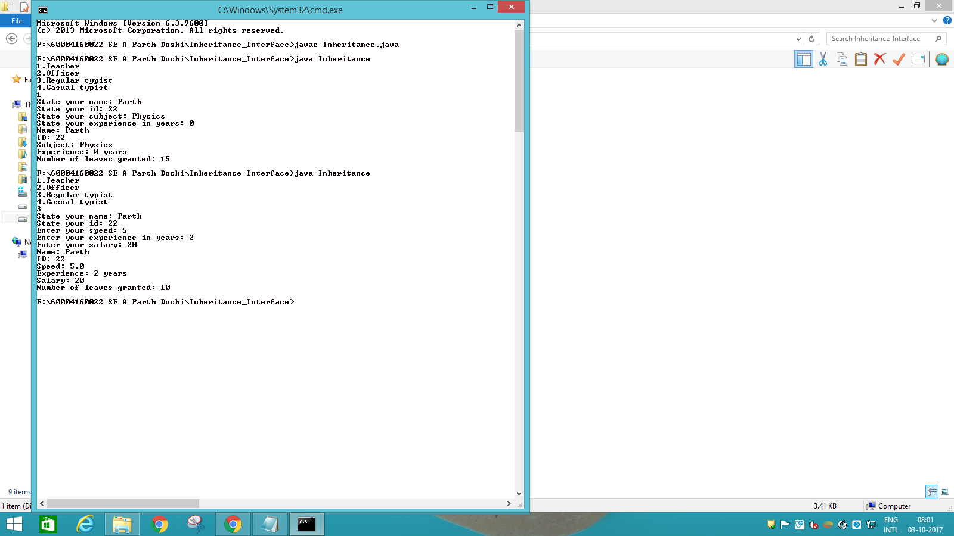



**Part 2**

import java.util.*;

public class Interexp {

public static void main(String[] args) {

Scanner sc = new Scanner(System.in);

Bank b = new Bank();

int c;

do {

System.out.println("Menu\n1.New Account\n2.Withdraw\n3.Deposit\n4.Loan\n5.Display\n6.Exit");

c = sc.nextInt();

float amt;

switch(c) {

case 1:

b.new_acc();

break;

case 2:

System.out.print("Enter the amount to be withdrawn: ");

amt = sc.nextFloat();

b.withdraw(amt);

break;

case 3:

System.out.print("Enter the amount to be deposited: ");

amt = sc.nextFloat();

b.deposit(amt);

break;

case 4:

System.out.print("Enter the amount to be loaned: ");

amt = sc.nextFloat();

b.loan(amt);

break;

case 5:

b.display();

break;

case 6:

break;

default:

System.out.println("You have entered an invalid choice. Please try again.");

}

} while(c != 6);

}

}

interface OpenAcc {

void new_acc();

}

interface Transaction {

void withdraw(float amt);

void deposit(float amt);

}

interface Loan {

void loan(float amt);

}

class Bank implements OpenAcc, Transaction, Loan {

int acc_no;

String acc_type;

String cust_name;

float bal, loan_amt;

static Scanner sc = new Scanner(System.in);

public void new_acc() {

System.out.print("Enter the customer name: ");

cust_name = sc.next();

System.out.print("Enter the account number: ");

acc_no = sc.nextInt();

System.out.print("Enter the account type: ");

acc_type = sc.next();

System.out.print("Enter the initial balance: ");

bal = sc.nextFloat();

}

public void display() {

System.out.println("Customer name: " + cust_name);

System.out.println("Account number: " + acc_no);

System.out.println("Account type: " + acc_type);

System.out.println("Balance: " + bal);

System.out.println("Loan: " + loan_amt);

}

public void withdraw(float amt) {

if (amt > bal) {

System.out.println("You cannot withdraw this amount. There is a deficit of " + (amt-bal) + " in your account");

return;

}

bal = bal - amt;

System.out.println("You have withdrawn " + amt + ". You have " + bal + " left in your account.");

}

public void deposit(float amt) {

bal = bal + amt;

System.out.println("You have deposited " + amt +". You have " + bal +" left in your account.");

}

public void loan(float amt) {

if (loan_amt > 0) {

System.out.println("You already have an outstanding loan. We cannot give you another loan at this time.");

return;

}

loan_amt = amt;

System.out.println("You have taken a loan of " + loan_amt +".");

System.out.println("You will have monthly payments of " +(0.1*loan_amt) +" until you have repaid " + (2*loan_amt) + ".");

}

}

